# Select and Inspect Index Components (Updated)

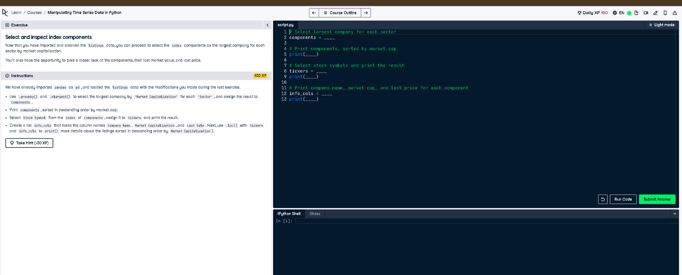

## ✅ Updated Full Correct Code:

# Select largest company for each sector  
components = listings.groupby("Sector")["Market Capitalization"].nlargest(1)  
  
# Print components, sorted by market cap  
print(components.sort_values(ascending=False))  
  
# Select stock symbols and print the result  
tickers = components.index.get_level_values("Stock Symbol")  
print(tickers)  
  
# Print company name, market cap, and last price for each component (sorted by market cap)  
info_cols = ["Company Name", "Market Capitalization", "Last Sale"]  
print(listings.loc[tickers, info_cols].sort_values("Market Capitalization", ascending=False))

## 📘 Explanation (Simple Terms):

This code selects the top company by market cap in each sector using .groupby() and .nlargest(). It then prints these, grabs their stock symbols, and shows the company name, market cap, and last sale — all sorted in descending order by market cap for better clarity and comparison.